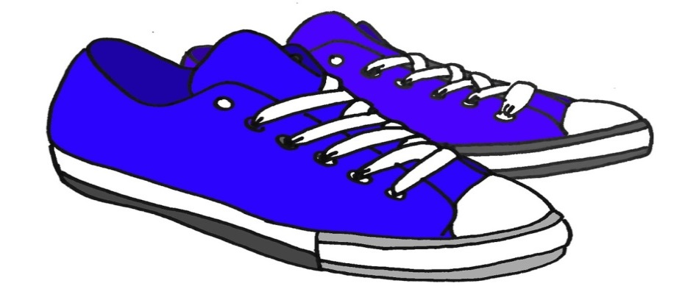

You are all invited to join our ANNUAL spring STEP Challenge!

Only employees who subscribe to our BCBS health insurance are able to participate.

The enrollment period for the Spring Step Challenge is from April 5, 2021 to April 18, 2021.
.
Challenge will begin April 12, 2021 and will end on May 24, 2021 at 11:59pm.

Step challenge instructions are available on the district website

SPRING 2021 STEP CHALLENGE INSTRUCTIONS

To successfully complete this challenge, you will need to log 294,000 steps within 6 weeks, an average of 7,000 steps a day, using a pedometer, Fitbit® or other device to keep track of steps. Steps must be entered into ahealthyme, either on the website, through the HealthyNow app, or through a connected Fitbit® device, to be counted toward the challenge goal.

All employees that join the challenge will be entitled to the Fitbit Inspire 2 even if you received a Fitbit in the past!

Please contact Marcia Tome in the Benefits Office at 508-997-4511 Ext. 14355 or email mtome@newbedfordschools.org to claim your Fitbit.

Employees who complete the challenge will be eligible to receive a $25.00 gift certificate.

Gift certificates will be issued to employees only.

