Name of Child: ________________________

These skills will help your child be successful in Preschool. In Kindergarten, these skills will be important for your child's success as we begin to focus on academic growth. Please highlight or circle the skills that your child can do at this time and turn in to your child's teacher for a prize ☺
Self Care | Social Emotional | Communication | Kindergarten Readiness
Dress and undress themself independently.  (Can your child button their pants, zip up their coat, put their coat on?) | Follow rules and two step directions.  (Take off coat and backpack and put away). | Express wants and needs.  (Can they ask for help when they need it? Can they ask for something if they want it?) | Although these skills are geared toward Kindergarteners, these are the skills we will introduce in preschool. We encourage preschool students to attempt these skills at home.
Express the need to use the toilet.  (Does your child wait until the last second to ask? Do they tell you or just go?) | Shares and takes turns.  (Can they wait patiently to use a toy or material they are interested in? Be willing to let another child use it after their turn?)  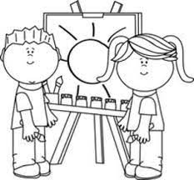 | Speak clearly enough to be understood.  (Can they communicate clearly back and forth? Can others easily understand them?)  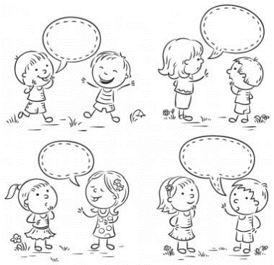 | Fine Motor Skills  1. Use writing utensils with pincer grasp (pencil, crayon etc).  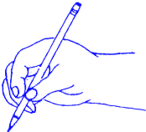  2. Use scissors safely (thumb in small hole, three fingers in the other).  3. Build and pull apart manipulatives(push together and pull apart).
Take care of their own toileting needs.  (Can they pull up/down their pants independently? Can they button them independently? Can they wipe alone? Wash their hands independently?) | Self control of voice and body (depending on situation).  (Library behavior vs. playground behavior) | Personal Facts.  (Can they tell you their name when asked? Do they know they are in Preschool? Do they know their guardians' names?) | Reading  1. Can identify and write first name.  2.Identify letters in their own name (if they can, start other letters in the alphabet.)  3. Hold and use books appropriately.  4. Can draw a picture independently and tell about it.  5. Listen to a story and answer questions after.
Open containers and food packaging on their own (or attempt).  (Can they use utensils independently? Can they drink from a straw?) | Expresses emotions appropriately.  (Can they ask for help from an adult if needed? Can they control their body when upset?) | Be comfortable having a back and forth conversation with an adult or peer.  (Can they wait to speak while someone else is talking? Can they answer questions?) | Math  1. Say numbers in order from 0-10.  2. Count up to 10 objects and tell how many there are.  3. Match a number with a quantity.  4. Can name basic colors and 2-D shapes.

