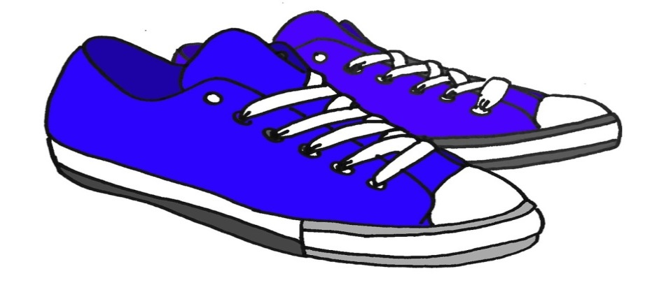

You are all invited to join OUR fall STEP Challenge!

Only employees who subscribe to our BCBS health insurance can participate.

The enrollment period for the Fall Step Challenge is from September 5, 2022 – September 18, 2022
.
Challenge will begin September 12,2022 and will end on October 24 ,2022 at 11:59pm.

Step challenge instructions are available on the district website click on this link
BENEFITS

To successfully complete this challenge, you will need to log 294,000 steps within 6 weeks, an average of 7,000 steps a day, using a pedometer, Fitbit® or other device to keep track of steps. Steps must be entered into ahealthyme, either on the website, through the HealthyNow app, or through a connected Fitbit® device, to be counted toward the challenge goal.

All employees and dependents that join the challenge will be entitled to the Fitbit Inspire 2 if they did not receive one on the previous challenge while supplies last!

Please contact Marcia Tome in the Benefits Office at 508-997-4511 Ext. 14355 or email mtome@newbedfordschools.org to claim your Fitbit.

Employees who complete the challenge will be eligible to receive a $25.00 gift certificate.

Gift certificates will be issued to employees only.

